**ELASTIC COMPUTE CLOUD**

**PART-1**

* EC2 called as Virtual Machine in AZURE. And also called as "Virtual Server" and "Instance"
* EC2 provides scalable computing capacity in the AWS cloud. - Using Amazon EC2 eliminates your need to invest in hardware in front so you can develop and deploy application traffic.
* You can use Amazon EC2 to launch as many or as few virtual servers as you need, configure security and networking, and manage storage.
* Amazon EC2 enables you to Scale up or Scale down the instance.
* Amazon EC2 is having two storage options i.e.. EBC (outside physical server) and Instance Store (inside physical server [fast and non-persistant]).
* Pre-configured templates are available known as Amazon Machine Image.
* By default, when you create an EC2 account with amazon, your account is limited to a maximum of 20 instances per EC2 Region with default High I/O instance.

Types of Amazon EC2 Instances:

1. General Purpose: Balance Memory and CPU
2. Compute Optimized: More CPU than RAM
3. Memory Optimized: More RAM
4. Accelerated Computing/GPU: Graphics Optimized (PubG game)
5. Storage Optimized: Low latency
6. High Memory Optimized: High RAM , Nitro System (Nitro System is like a hypervisor)
7. Previous Generation.

Type 1: General Purpose Instance

* General purpose instances provide a balance of compute, memory and networking resources and can be used for a variety of workloads.
* 3 Series in General Purpose:

1. A Series:
   1. A1 : (Medium , Large)
2. M Series : (Large)
   1. M4
   2. M5
   3. M5a
   4. M5ad
   5. M5d
3. T Series :
   1. T2 : t2-micro (free tier eligible)
   2. T3
   3. T3a

* Instances available in four sizes – Nano, Small, Medium, Large.
* A1 Instances:
  + A1 instances are ideally suited for scale-out workloads that are supported by the Arm Ecosystem.
    - ARM Ecosystem of software partners provide customers a wide range of products to gets to market faster that the competition. Arm development boards are the ideal platform for accelerating the development and reducing the risks of new SOC design.
  + These instances are well suited for the following application:
    - Webserver
    - Containerized micro services
    - Caching fleets:
      * Cache is a high-speed data storage layer which stores a subset of data, typically transient in nature, so that future request for that data are served up faster.
    - Distributed data stores
    - Application that Requires Arm Instruction Set
* M Series : 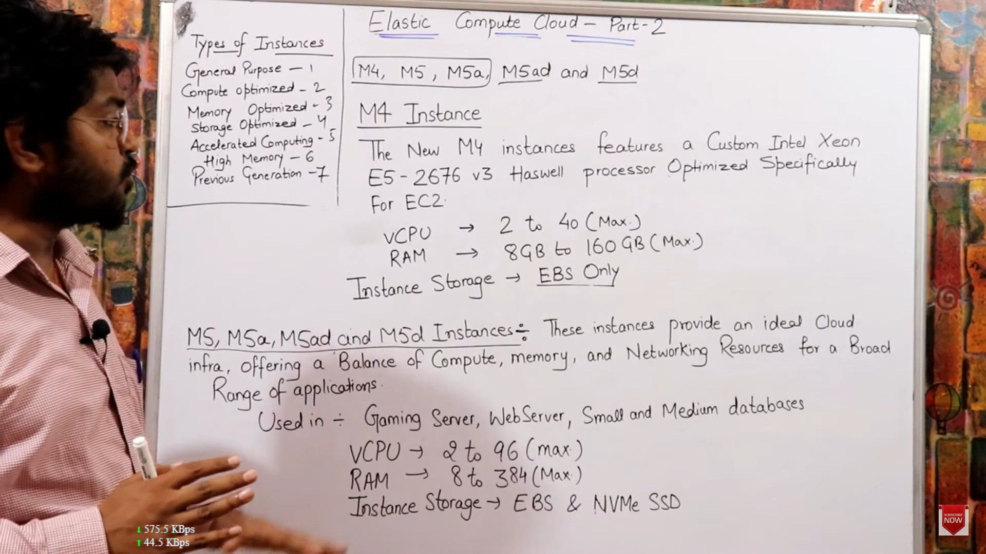
* T Series :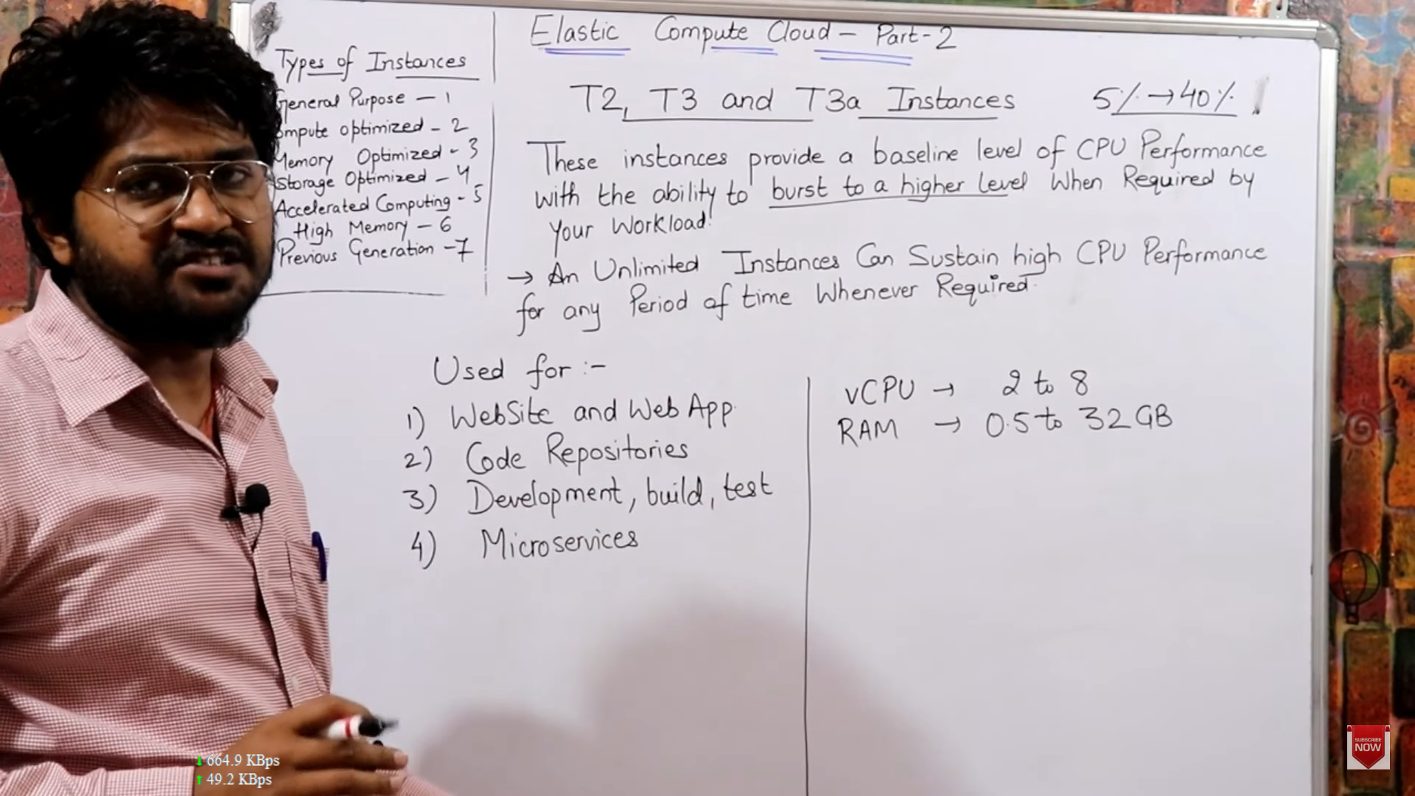

Type-2 Compute Optimized

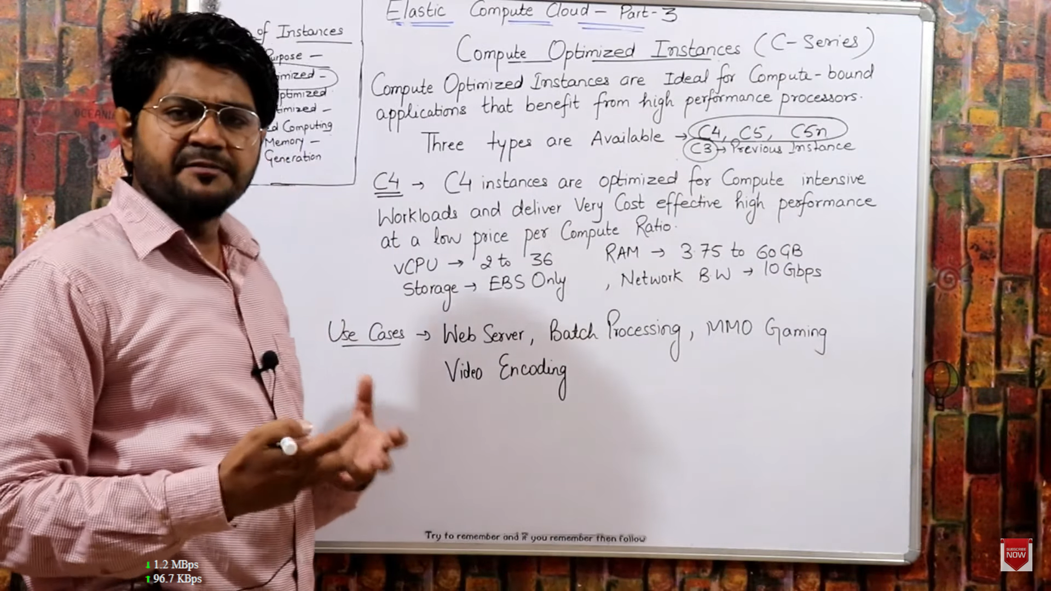

* + C3 is a type of compute optimized now moved to “Previous Generation” type, and AWS updated version of C3 called C5, which is 25% faster and lower cost.
  + C5 is cost effective and faster than C4 and C3.
* 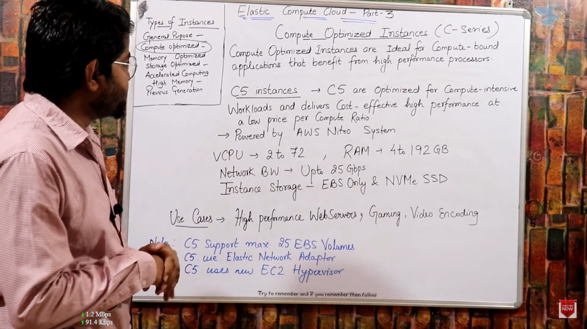

Type-3 Memory Optimized Instance

* 3 Series in Memory Optimized:
  + R Series
    - R4
    - R5
    - R5ad
    - R5d
  + X Series: Max RAM (Biggest in AWS)
    - X1
    - X1e Instances
  + Z Series: Max Freq (4Ghz)
    - Z1d: middle of R and X series
  + 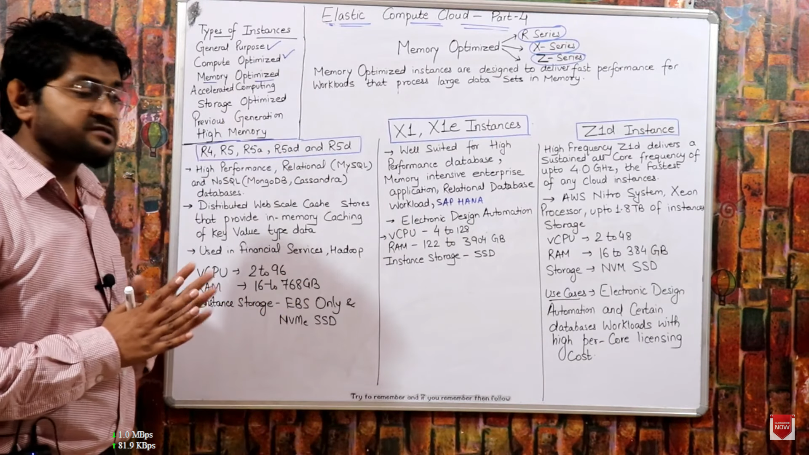

Type 4 : STORAGE OPTIMIZED INSTANCES

* Whenever require high amount of storage, like youtube videos, songs
* Storage optimized instances are designed for workloads that requires high sequential (one after another) read and write access to very large data sets on local storage.
* 3 Series:
  + I (i) : Minimum Memory
    - I3
    - I3EN (latest)
  + D : Medium Memory
    - D2
  + H : Large Memory
    - H1

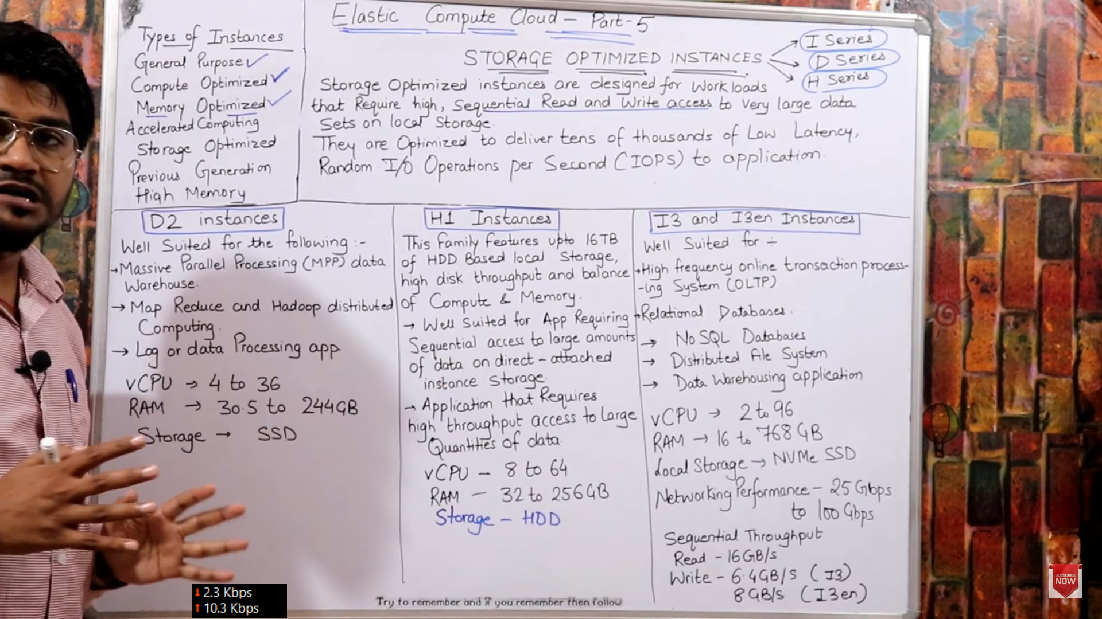

Type 5 : Accelerated Computing Instances

* Graphics card
* Use in Facebook, Insta live streaming. 3D game
* Use in AI, ML and DL (deep learning).
* Accelerated Computing Instances families use hardware accelerators or co-processors to perform some functions such as floating point number calculation, graphics processing or data pattern matching more efficiently than is possible in software running on CPUs.
* 3 Series :
  + P
  + G
  + F :
    - F1

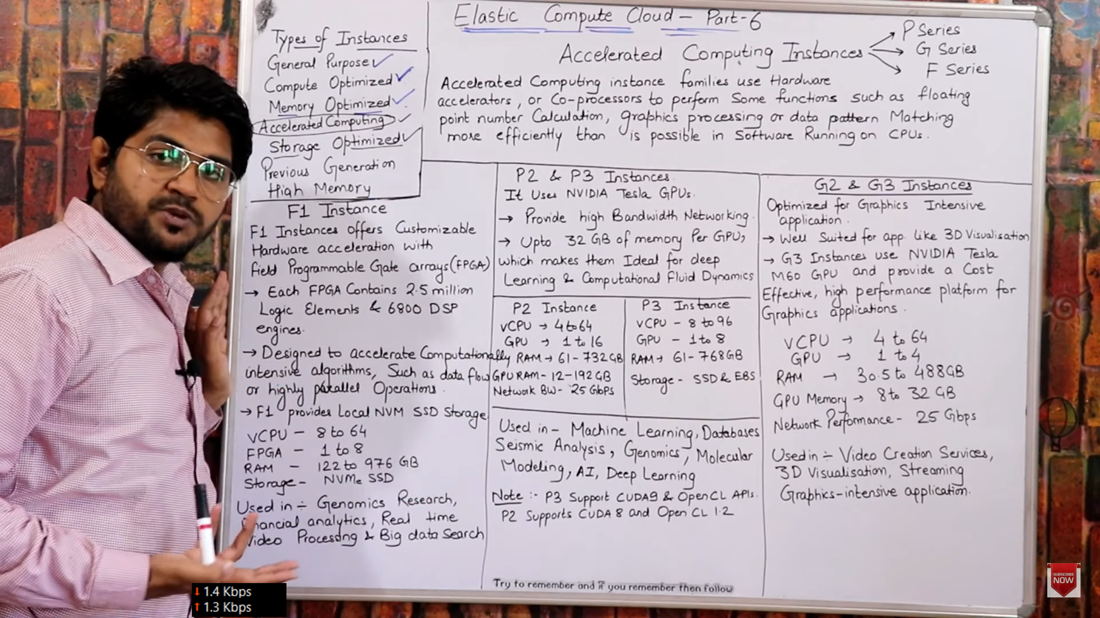

Type 6 : High Memory Instance

* Its different than all other types, its like super computer which runs on dedicates host, no hipervisor or virtualization concept, need to purchase dedicated host for dedication user for minimum 3 yrs from aws
* 1 series
  + U Series :
    - U6 : 6TB ram
    - U9
    - U12

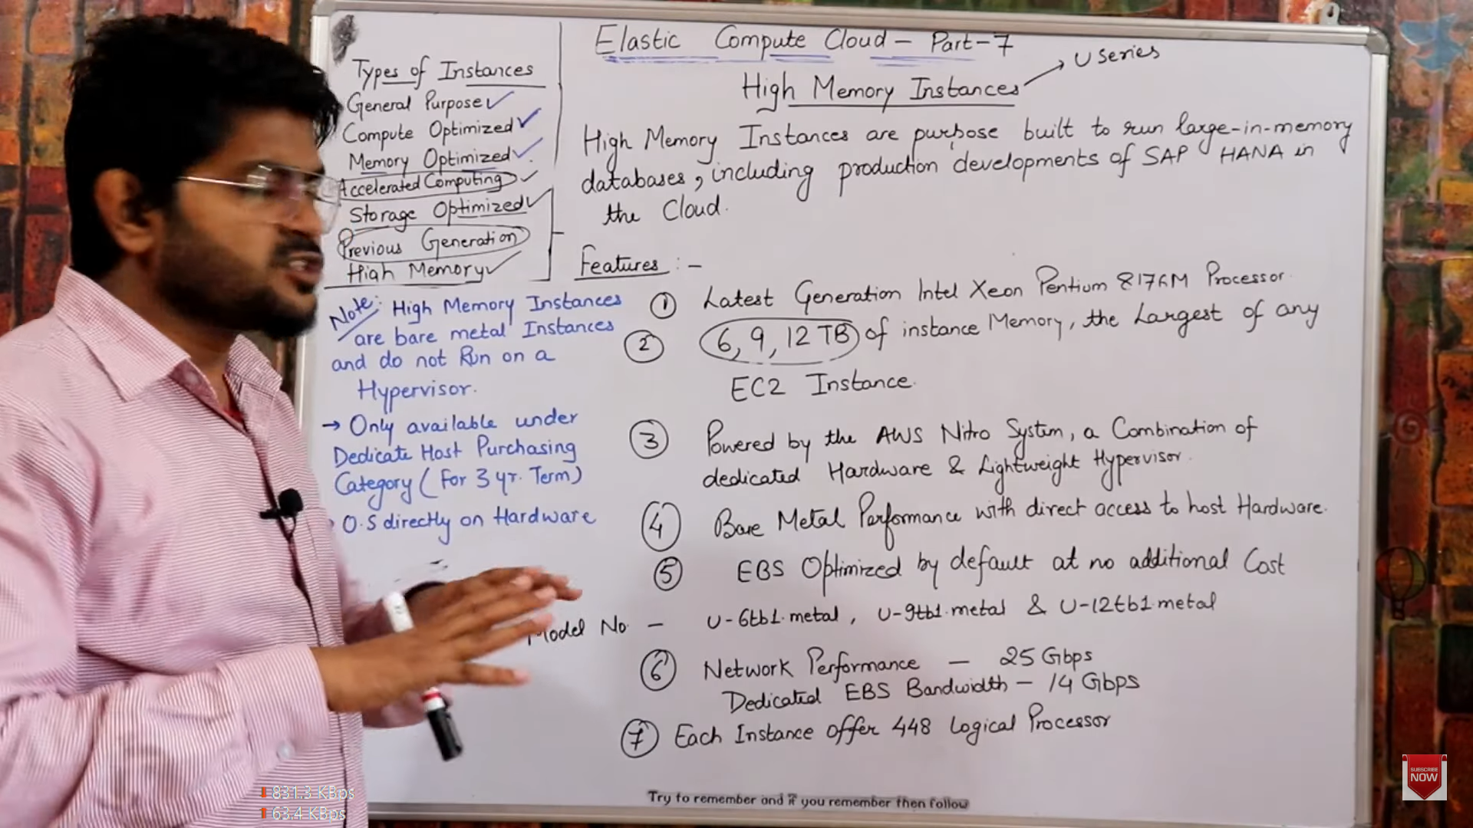

Type 7 : Previous Generation Instances

